Imix / Track Spotlight
MIX0106T
Series Name：
Model No：
Project name：
Location：

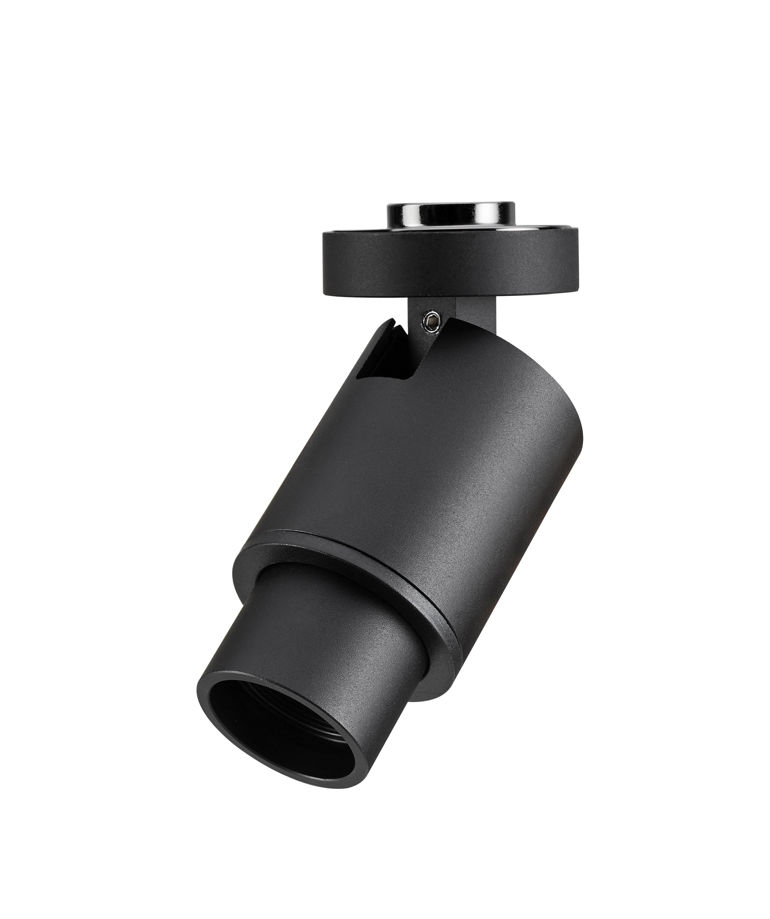
Specification
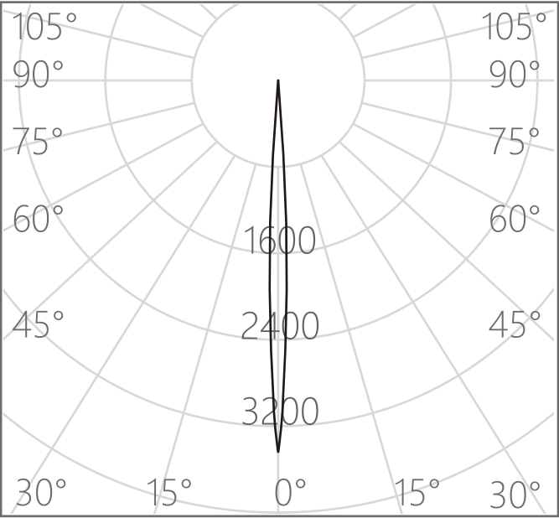
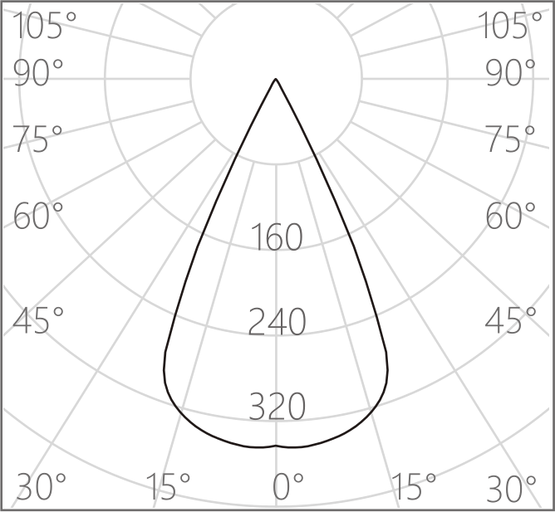
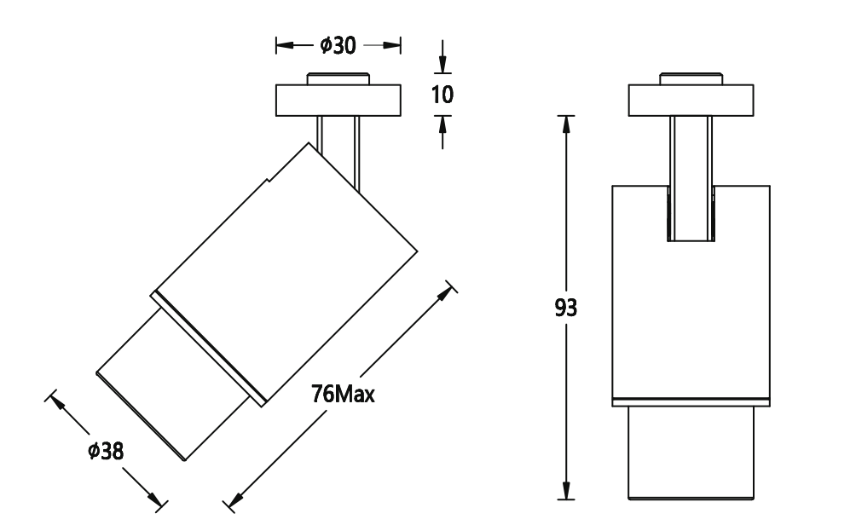
LED Source
CCT
CRI
SDCM
Life Span
Wattag3
Beam
Input Voltage
Installation
Cut-ou5
Adjustment Range
Material
Finish and Color

Certification
IP Rating

：LED SMD
：3000K/4000K
：Ra 97
：≤ 2
：>50000h-L90/B10
：6W
：6°- 40°
：DC 12V/450mA Max
：Magnetic surface mounting
：15mm
：Horizontal 0°～360°，Vertical 90°
：Integrated aluminum alloy lamp body
：Anodizing/Anti-corrosion electrostatic spraying
Oxidized Black/Matt White
：CCC / CE
：IP20

MDC-8P
Adapter cable
MDC0400-1SL
CC Driver

CE3.3A-24SH-D
CV Driver 80W

ME2.5A-24SL
CV Driver 60W
6°
40°
Accessories Available

