Imix / Track Spotlight
MIM0409W
Series Name：
Model No：
Project name：
Location：

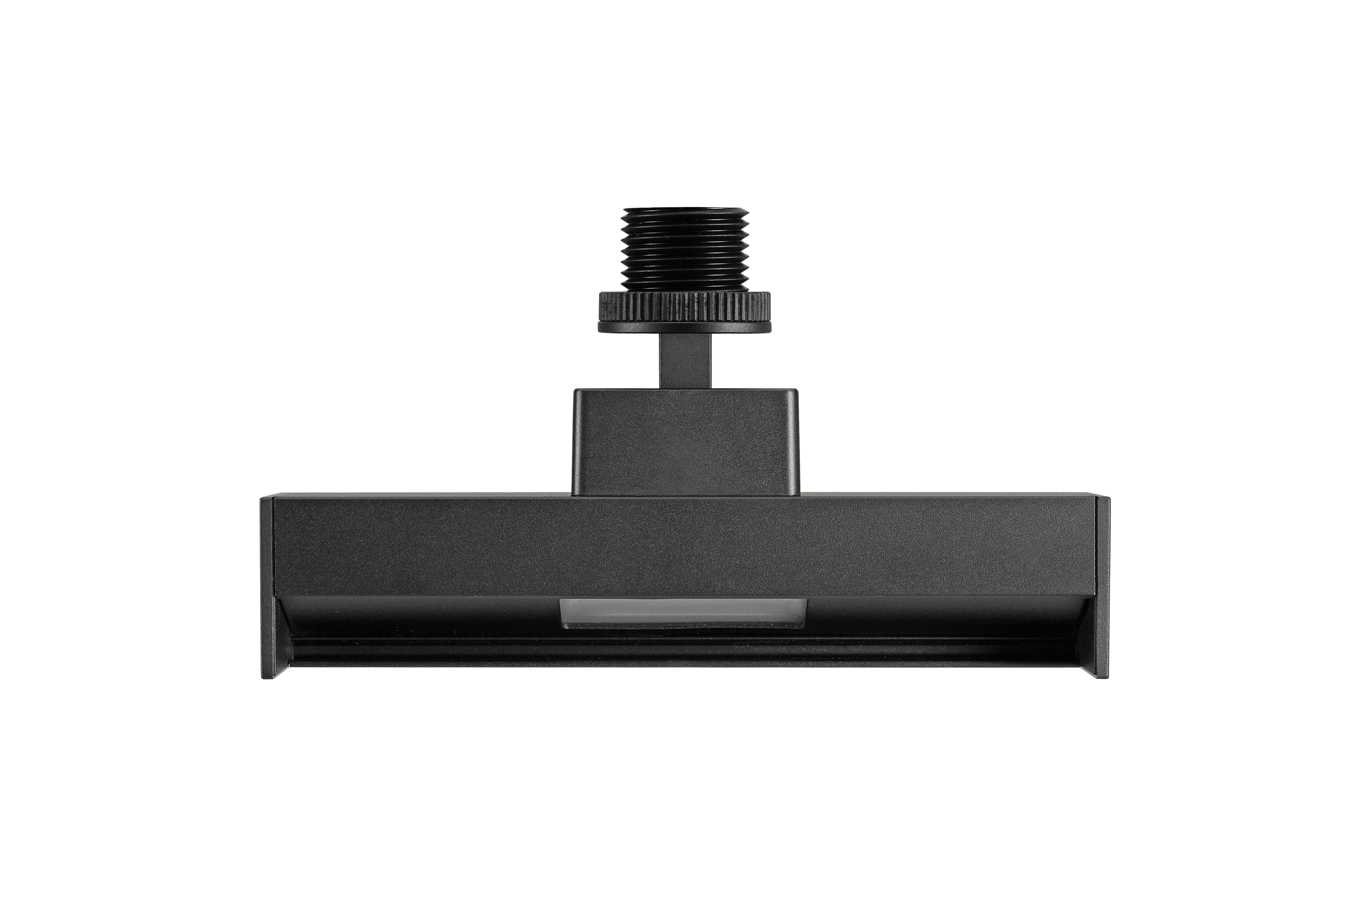
Specification
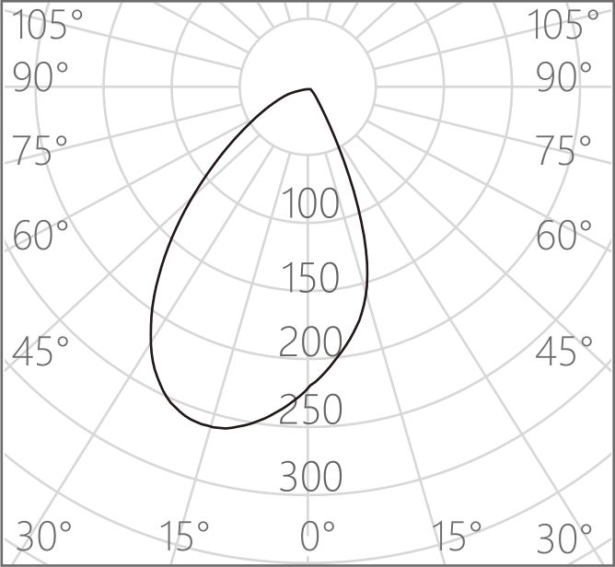
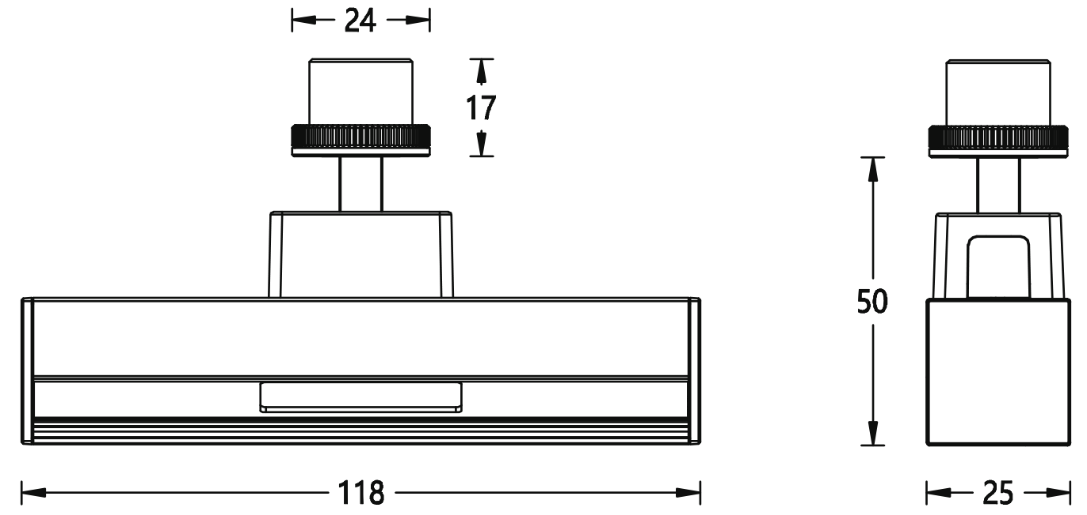
MDC-8P
Adapter cable
MDC0650-1SL
CC Driver

CE3.3A-24SH-D
CV Driver 80W

ME2.5A-24SL
CV Driver 60W
Wallwash
：LED SMD
：3000K/4000K
：Ra 97
：≤ 2
：>50000h-L90/B10
：9W
：Wallwash
：DC 12V/700mA Max
：Recessed Surface-mounted Installation
：18mm
：Horizontal 0°～360°，Vertical ±30°
：Integrated aluminum alloy lamp body
：Anodizing/Anti-corrosion electrostatic spraying
Oxidized Black/Matt White
：CCC / CE
：IP20

LED Source
CCT
CRI
SDCM
Life Span
Wattage
Beam
Input Voltage
Installation
Cut-out
Adjustment Range
Material
Finish and Color

Certification
IP Rating

Accessories Available

